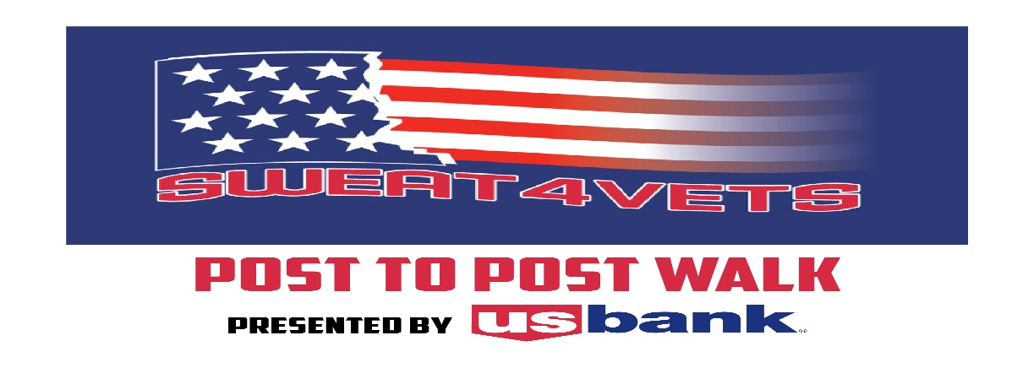

A Post-to-Post Walk Benefiting the Milwaukee VA Suicide Prevention Outreach

Brought to you by the Cedarburg & Grafton American Legion Auxiliary Units
Email: sweat4vetswi@gmail.com Phone: 920-851-3610

Name: _________________________________________________ Phone:______________________________ Email:_____________________________________________

Donor Name | Address | Phone or Email | Total $ Amount Pledged | Check # or Cash | Paid  (check box)
 |  |  | $
 |  |  | $
 |  |  | $
 |  |  | $
 |  |  | $
 |  |  | $
 |  |  | $
 |  |  | $
 |  |  | $
 |  |  | $
 |  |  | $
 |  |  | $
 |  |  | $
 |  |  | $
 |  |  | $
 |  |  | $
 |  |  | $
 |  |  | $

- Please make checks payable to ALA/Sweat4vets
- Donations/Pledges are due at registration or packet pick-up Total Donations: $ _________________
- Questions? Contact Amy Luft at 414-651-7300 or amyjluft@gmail.com

